New ABAP syntax:

<https://www.youtube.com/watch?v=wTPqpJZDak8>

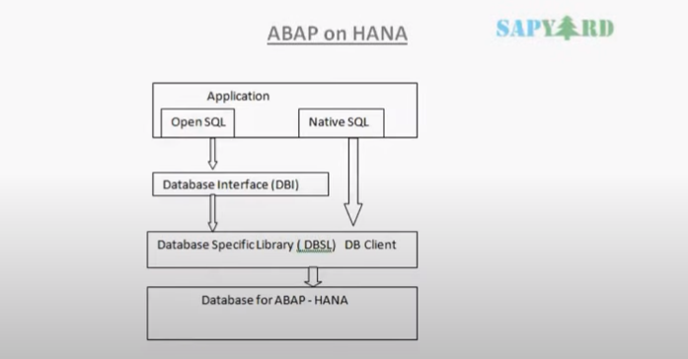

Select:

In older version declare the structure, based on that declare the internal table and then write the select query and pass those into the internal table.

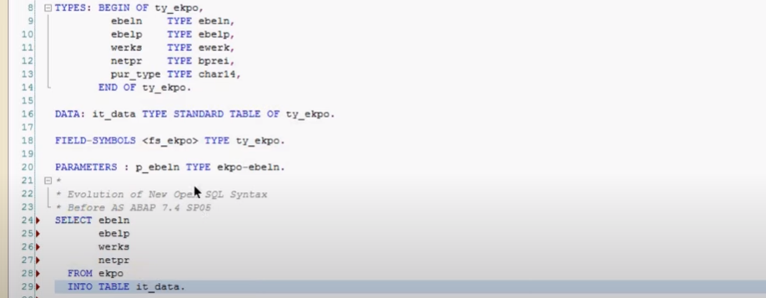

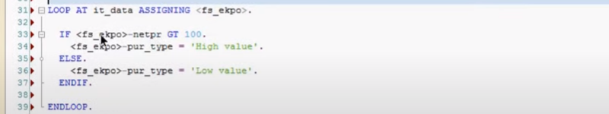

**As ABAP 7.4 SPO5**

1. Introduced as comma(,) separated in select query after my keyword select.
2. Order by, group by clause also comma(,) separated.
3. To store the data from select to internal table, sap has introduced the ‘@’ 🡪 old syntax escape with @ symbol.

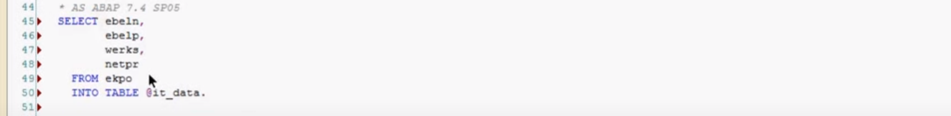

1. You can also use the “case” statement in select instead of above loop statement.

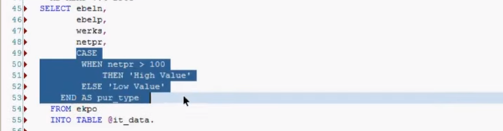

This calculation taken care database itself.

1. Another thing we brought inline declaration.-->@Data(it_data)

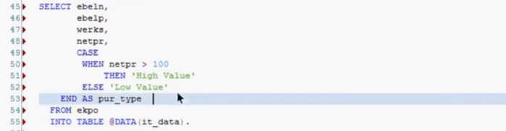

Based on select query parameters internal table created using syntax @Data(it_data) here it_data internal table.

1. Cl_demo_output->display_Data(exporting value = it_data).

Output:

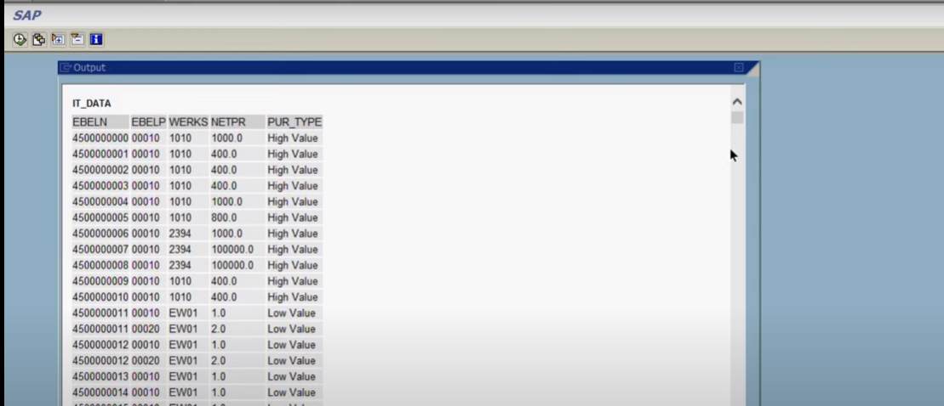

1. Important changes done in 7.5 they introduced “FILEDS” keyword and “Into” clause , this clause make the last statement for select query because 7.5 supports “union” and “union all”.

New syntax 7.5

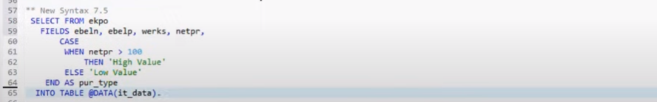

Why they brought:

🡪To increase the readability of the code.

🡪you will get all the fields from table using ctrl + space. And also get the detail of the field.

🡪for where clause in 7.5 you cant put after the “INTO” clause.

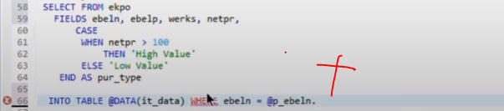

“Where” should be before the “INTO” clause.

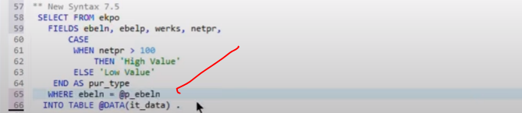

Output:

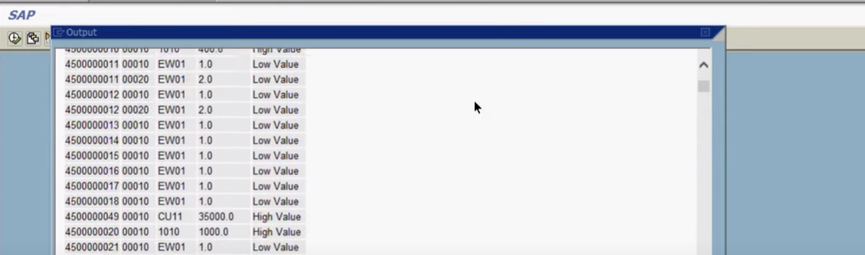

Result set

🡪Limitations in old syntax:

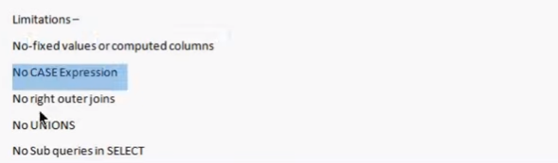

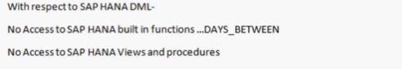

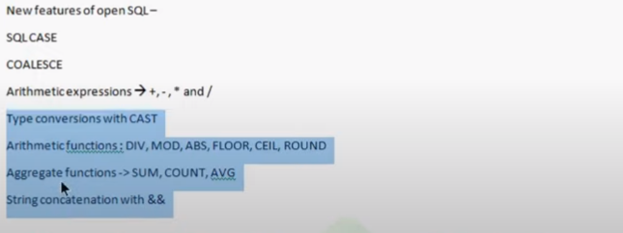

23:00

**String Concatenation: ‘&&’ suppose we have two columns i.e first name and last name and you want those to be concatenated into a single string this happen with in the same select query.**



* Right OUTER JOIN: available in OPEN SQL .
* MAXIMUM number of tables you can use in JOIN have been increased 250 this means in a single select query up to 250 tables can be each be joined using different join condition.
* Maximum number of sub queries also have been increased 250 there where earlier certain limitation while using joins and sub queries in ‘on’ condition, i.e you could not use operator like between, greater than, less than on the ‘on’ condition which is now possible.
* Earlier fields of the right table we could not use in the where clause of LEFT OUTER JOIN🡪 now it is possible.
* Union and Union all also will works. Earlier we use to do appending table when we had two select queries we had to append the data from second query into the same internal table which was populated in the first query so now that has been replaced with “UNION/UNION ALL”.
* In eclipse comment the code shift + ctrl + </>

Ex: 7.4 SP05

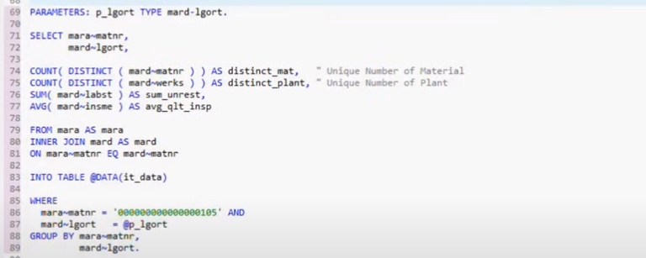

Here I have used the certain aggregation like count, sum, avg in my select queries.

Here counting distinct material number and distinct plant values these all are possible with new select query.

In select fields are comma separated this select query 7.4 SP05

In line decleration of internal table in select statement. @Data(it_data).

Group by clause is also comma(,) separated.

If you are using any field apart from once being aggregated function that should be used in group by clause, other wise it will give the error.all the fields which are not part of aggregate function have to be grouped by.

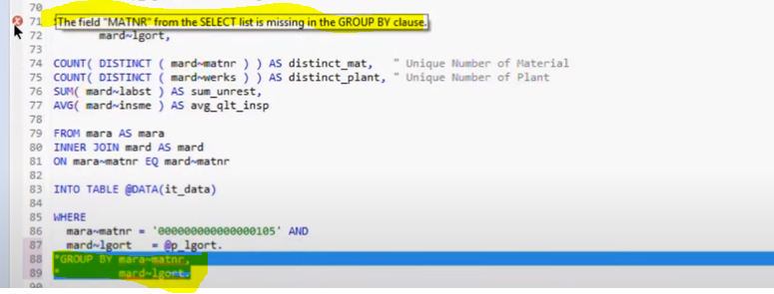

How to use the literals in select statement:-

Directly you can use the numeric literal and character literal as part of my selection list.

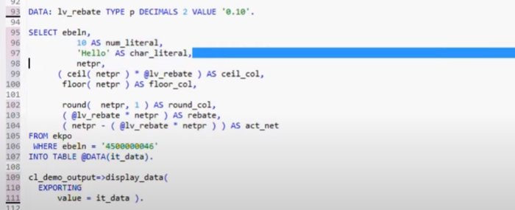

* 10 is numeric literal and “Hello” is character literal.
* Numeric_literal,char_literal, cell_col, round_col are alias names…..

And also I have used the certain arithmetic functions

* Ceil(netpr) * @lv_rebate 🡪 means once rounding of netpr value after that it is multiply with lv_rebate.

🡪apart from that I can also make use of system variables.

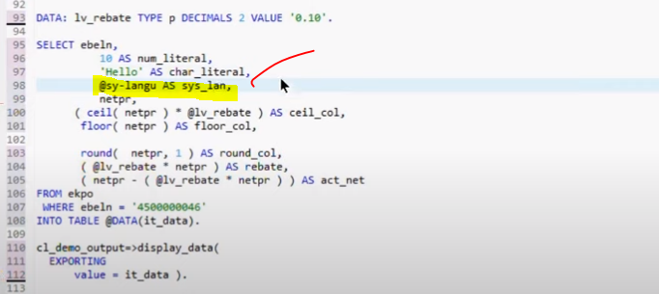

Output:

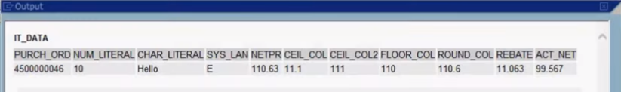

**Coalesce() function**

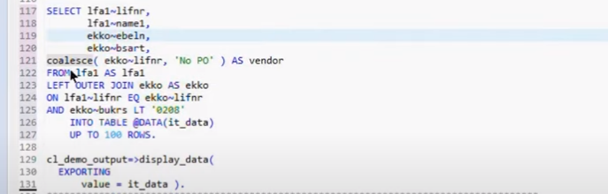

* Coalesce(ekko-lifnr, ‘No Po’) 🡪 used like as the if else condition.

Coalesce has 2 place holders if you have the value( not initial) then first value display(ekko-lifnr) else second value display(‘No Po’).

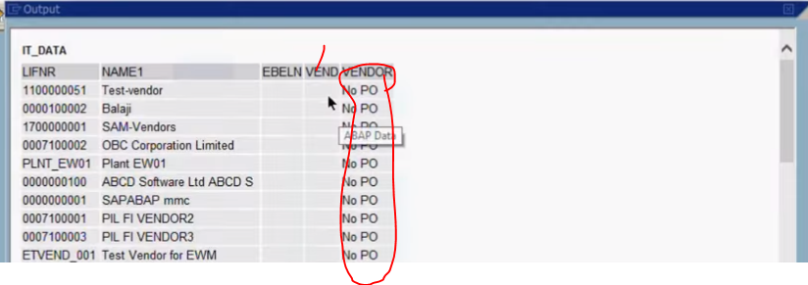

Concatenate function(&&)

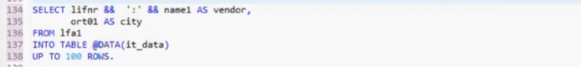

* Here I concatenated the vendor no and vendor name in same column using “&&”.

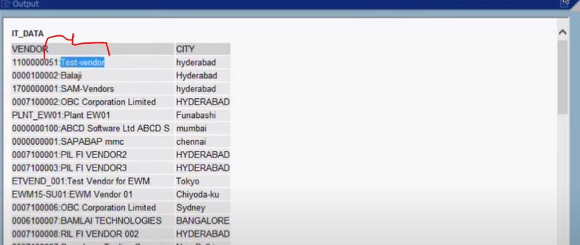

* Instead of “:” you could have provided the blank value also(@space)

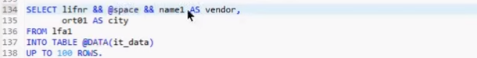

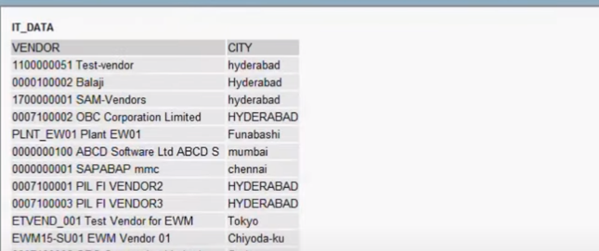

How to do validation for records exists with out sy-subrc.@abap_true

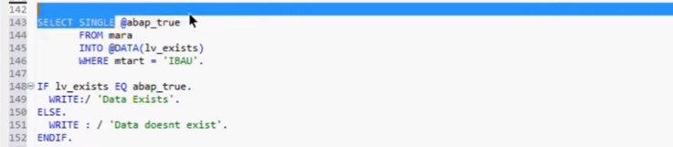

UNION and UNION ALL(used of instead of appending table)(7.5)

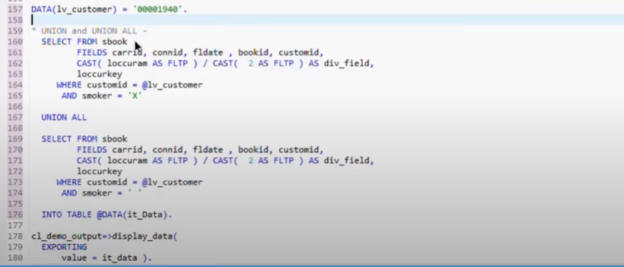

For union and union all into statement is the last statement.

Number of fields should be same in both the select queries.

Union all: holds the redundant entry.

Union: it will take all the records and then sort after the delete adjacent duplicates based on tables.

* Redundant not allowed.

CAST() in select: convert to another data type like cast( loccurm as fltp)/cast ( 2 as fltp )as div_field.

Number of fields in union must match.

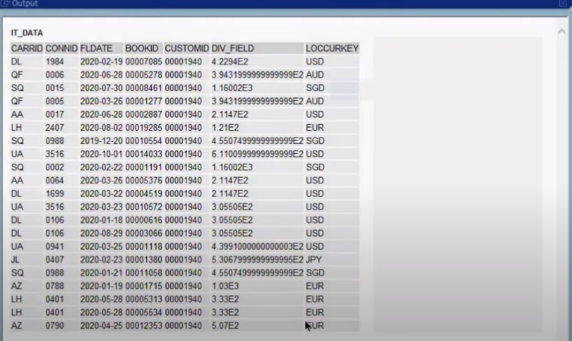

Differences old and new syntax(Read/concatenate)

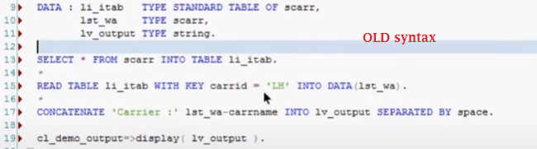



Inline declaration at function module:

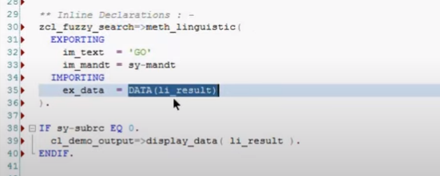

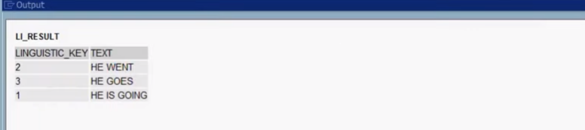

Creating the object:

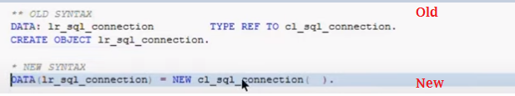

Structure and internal table:

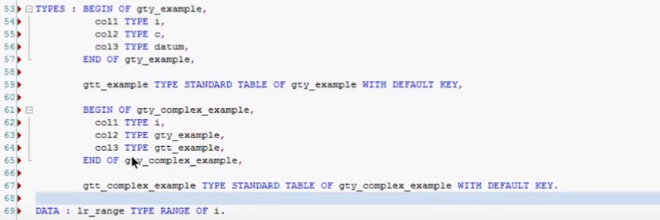

Structure declaration and assign value:



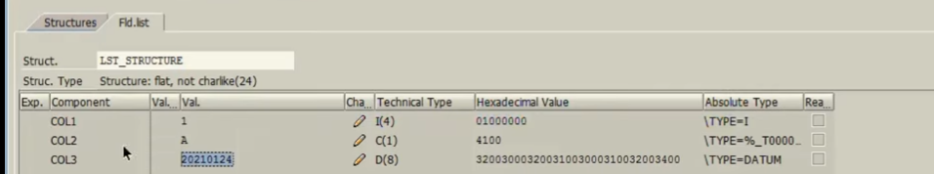

Internal table declaration and value assign to the internal table:



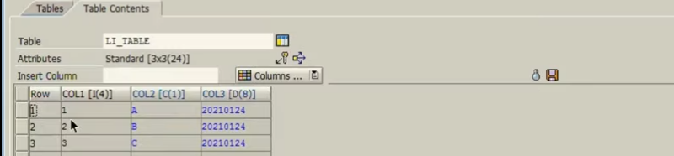

Assign data to complex structure:

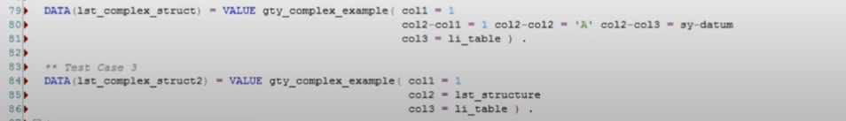

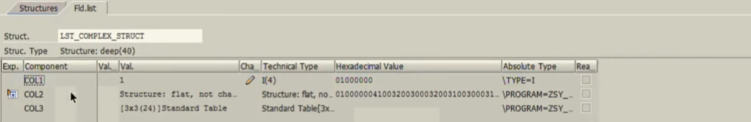

Data(variable) = value <structure type>/<internal type>( col1 = value1 col2 = val2… ).



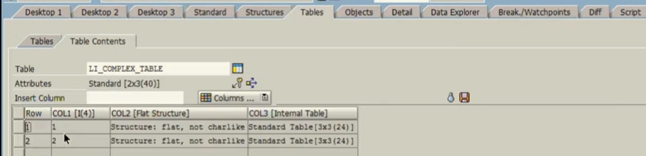

Range:

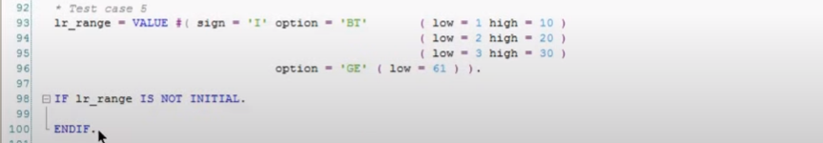

Here already lr_range object has declared so you can use “#”(instead types structure) while assigning the value.

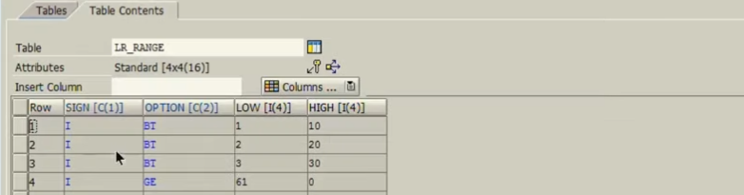

Classes: in “CONV #”

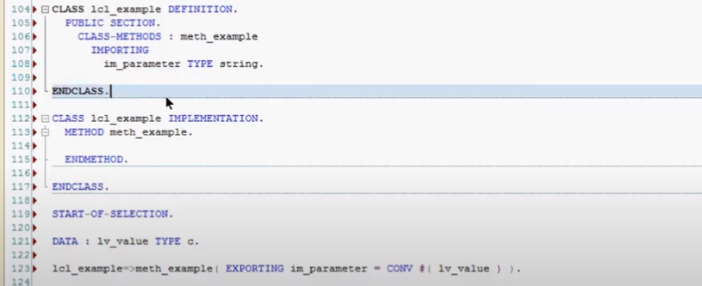

* I have declare the local class and it has local class methods which is meth_example and class implementation.
* Important thing to here to understand in methods we have declared the importing parameter of this method meth_example.
* Now we create the local variable lv_Value type character. But while compare to the method parameter and this are different.
* Now if you want to pass the lv_value, you can make it as type compatible with this “CONV#( lv_value). (by using the CONV #(….)).
* When you use the “conv #”, lv_value which gets pass to the input parameter will become type string.
* “CONV #” is very important when you calling the function module else it will through dump.
* CAST is used in select query.
* CONV # is used for while passing data to the FM, class methods and subroutines.

Corresponding

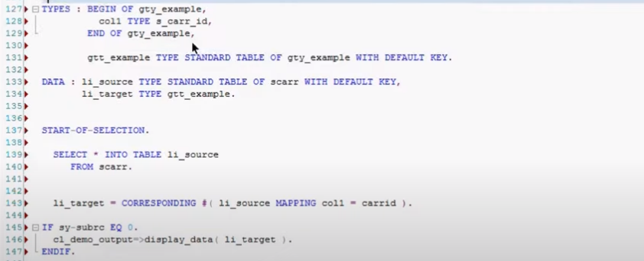

Certain number of columns are different compare to source and also names of column might be different.

Final target have one column i.e col1 type s_Carr_id , consider the case where if target internal table number of columns and also name of the columns is different and you want to make sure that this col1 gets populated with particular filed from li_soource table , so that we can use the “corresponding”,

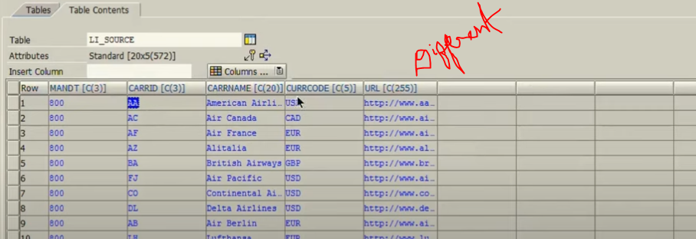

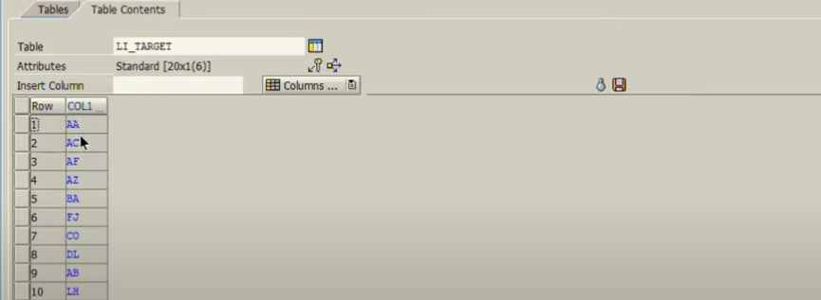

Ex:

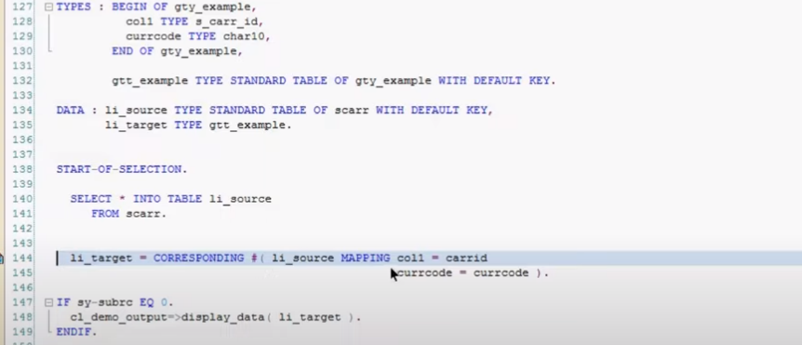

Manual passing “currcode”

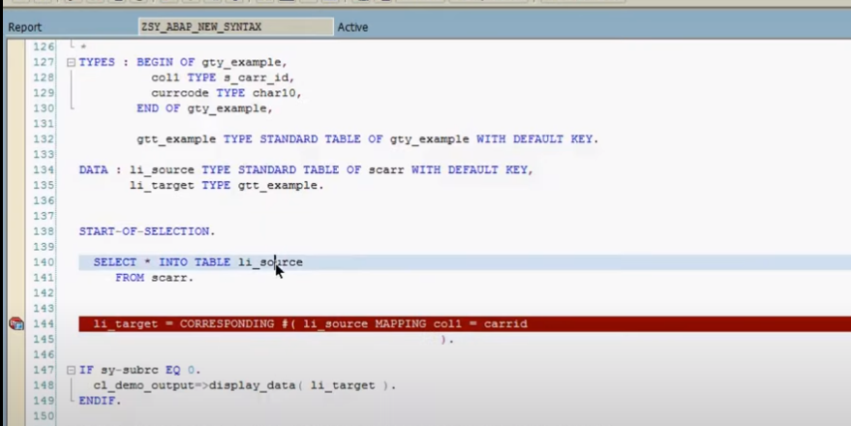

If column names are equal no need to mapping.. automatically transfer between.

1:20:00

How to do FILTER? And sending data to another internal table

Read statement and LOOP = FILTER

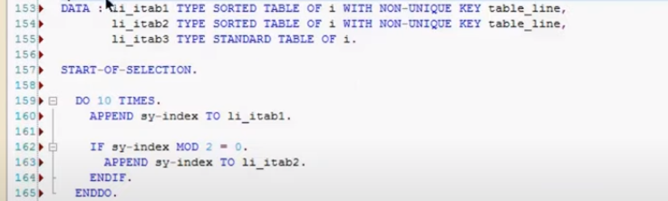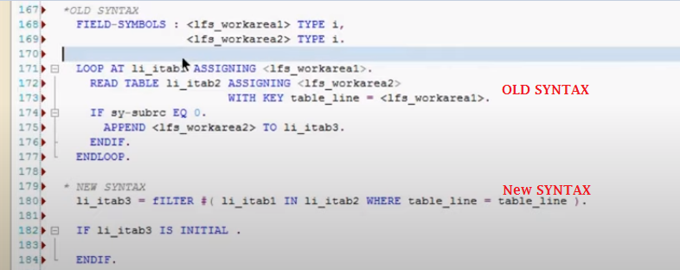

Output:

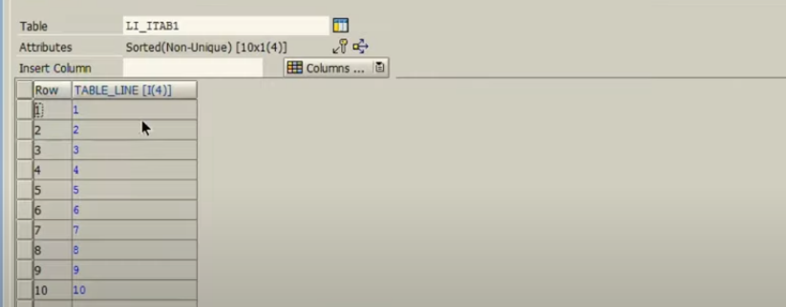

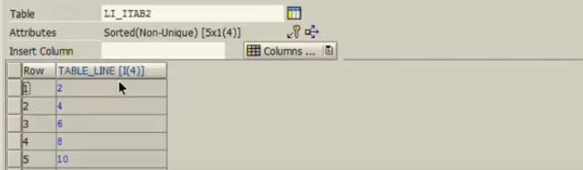

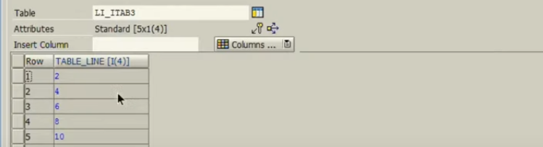

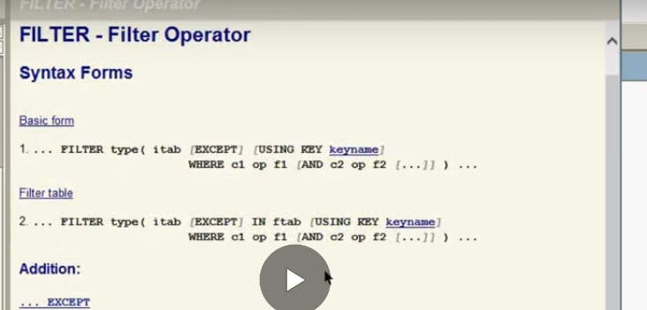

Except: is equal to “NOT IN” which are not part of li_itab2.

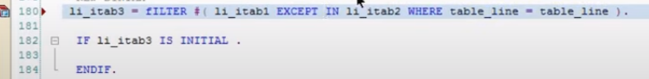

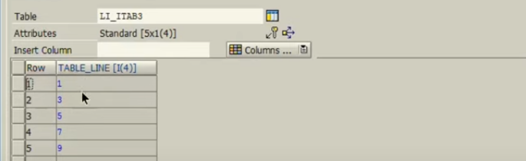

READ with INDEX:

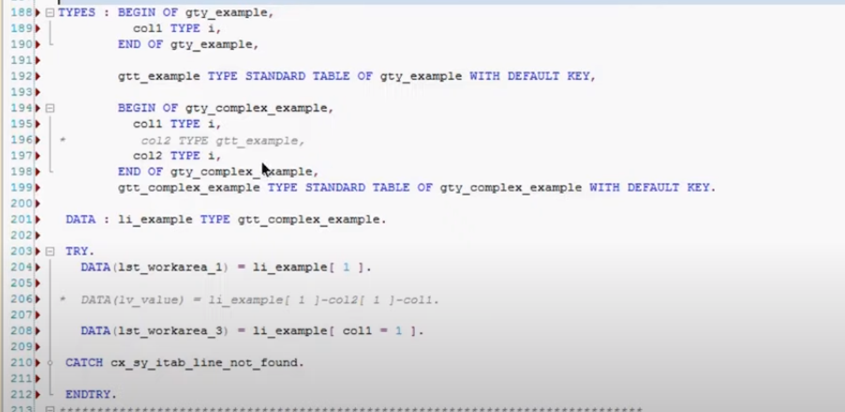

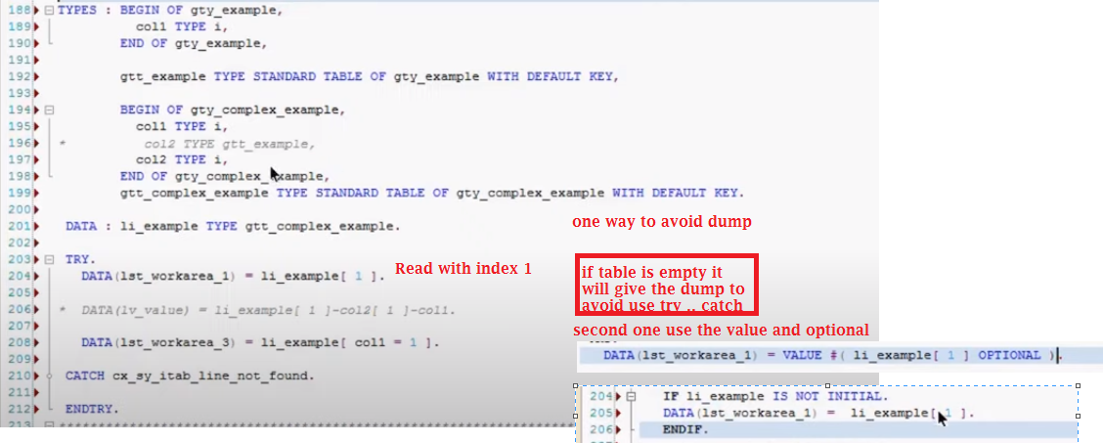

Line exists: 🡪READ Transporting no fields and SY-SUBRC

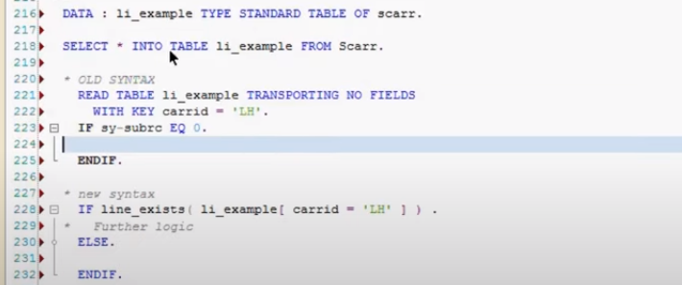

Read and find index: 🡪 line_index

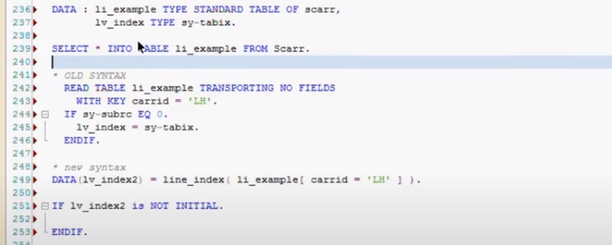

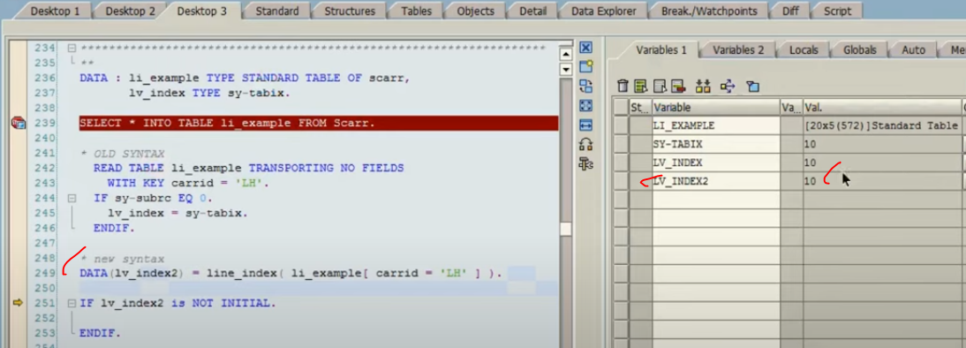

Loop along with group by statement:

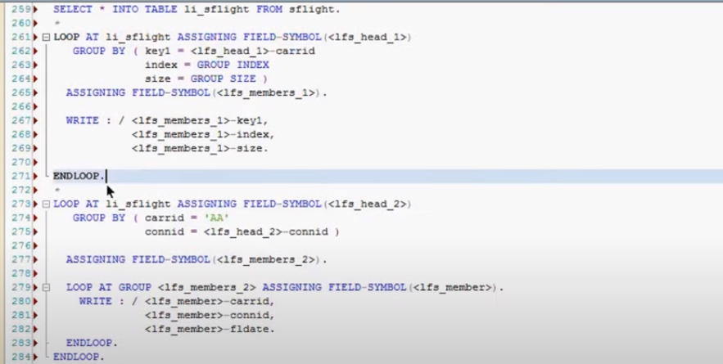

Earlier we have used for “at new” and “at end of “ between loop and endloop. In order to perform certain business requirement.

Using group by you can group particular data set of this internal table with the key which you mentioned here. And then you get bundle of data set. That data set you can play around.

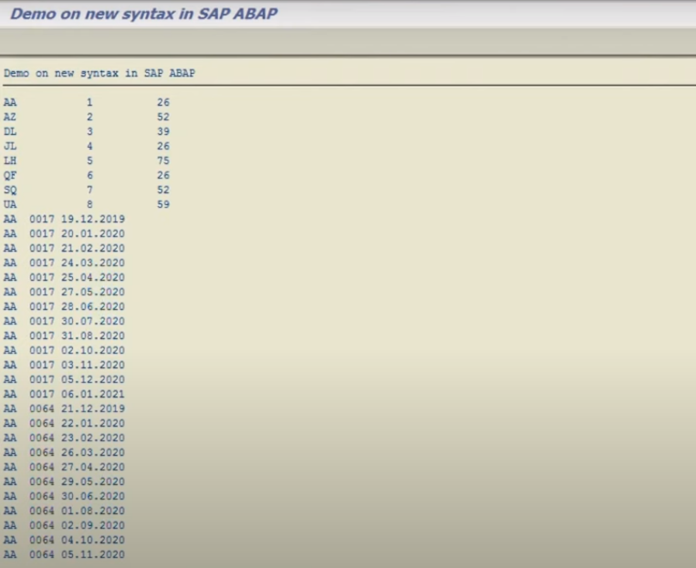

Loop at group: In second syntax group all the records and store it in temporary memory while doing the loop at group, it will pick one by one from temporary memory and display it.

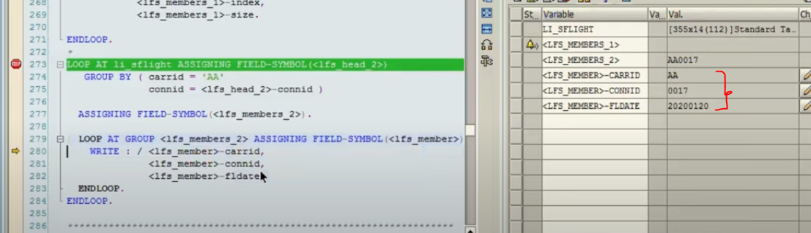

Loop has been replaced with for:

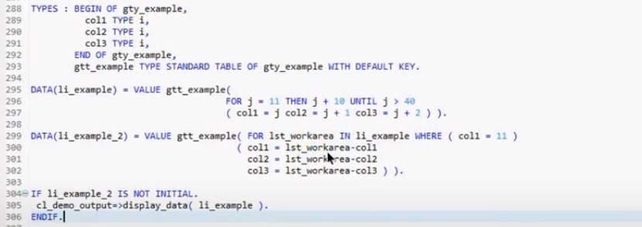

If you remove the where clause li_example_2 is equals to the li_example.

“For in” used to get the data from internal table.

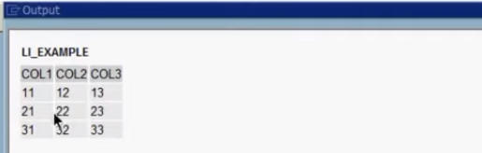

Lli_example_2 output:

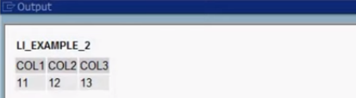

Value: means you are declaring with particular type.

COND:

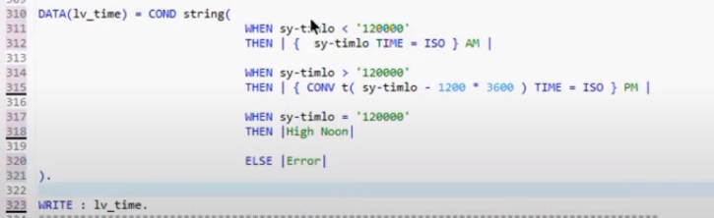

If it has condition then triggers, no condition – else will trigger.

It is like as case statement:

